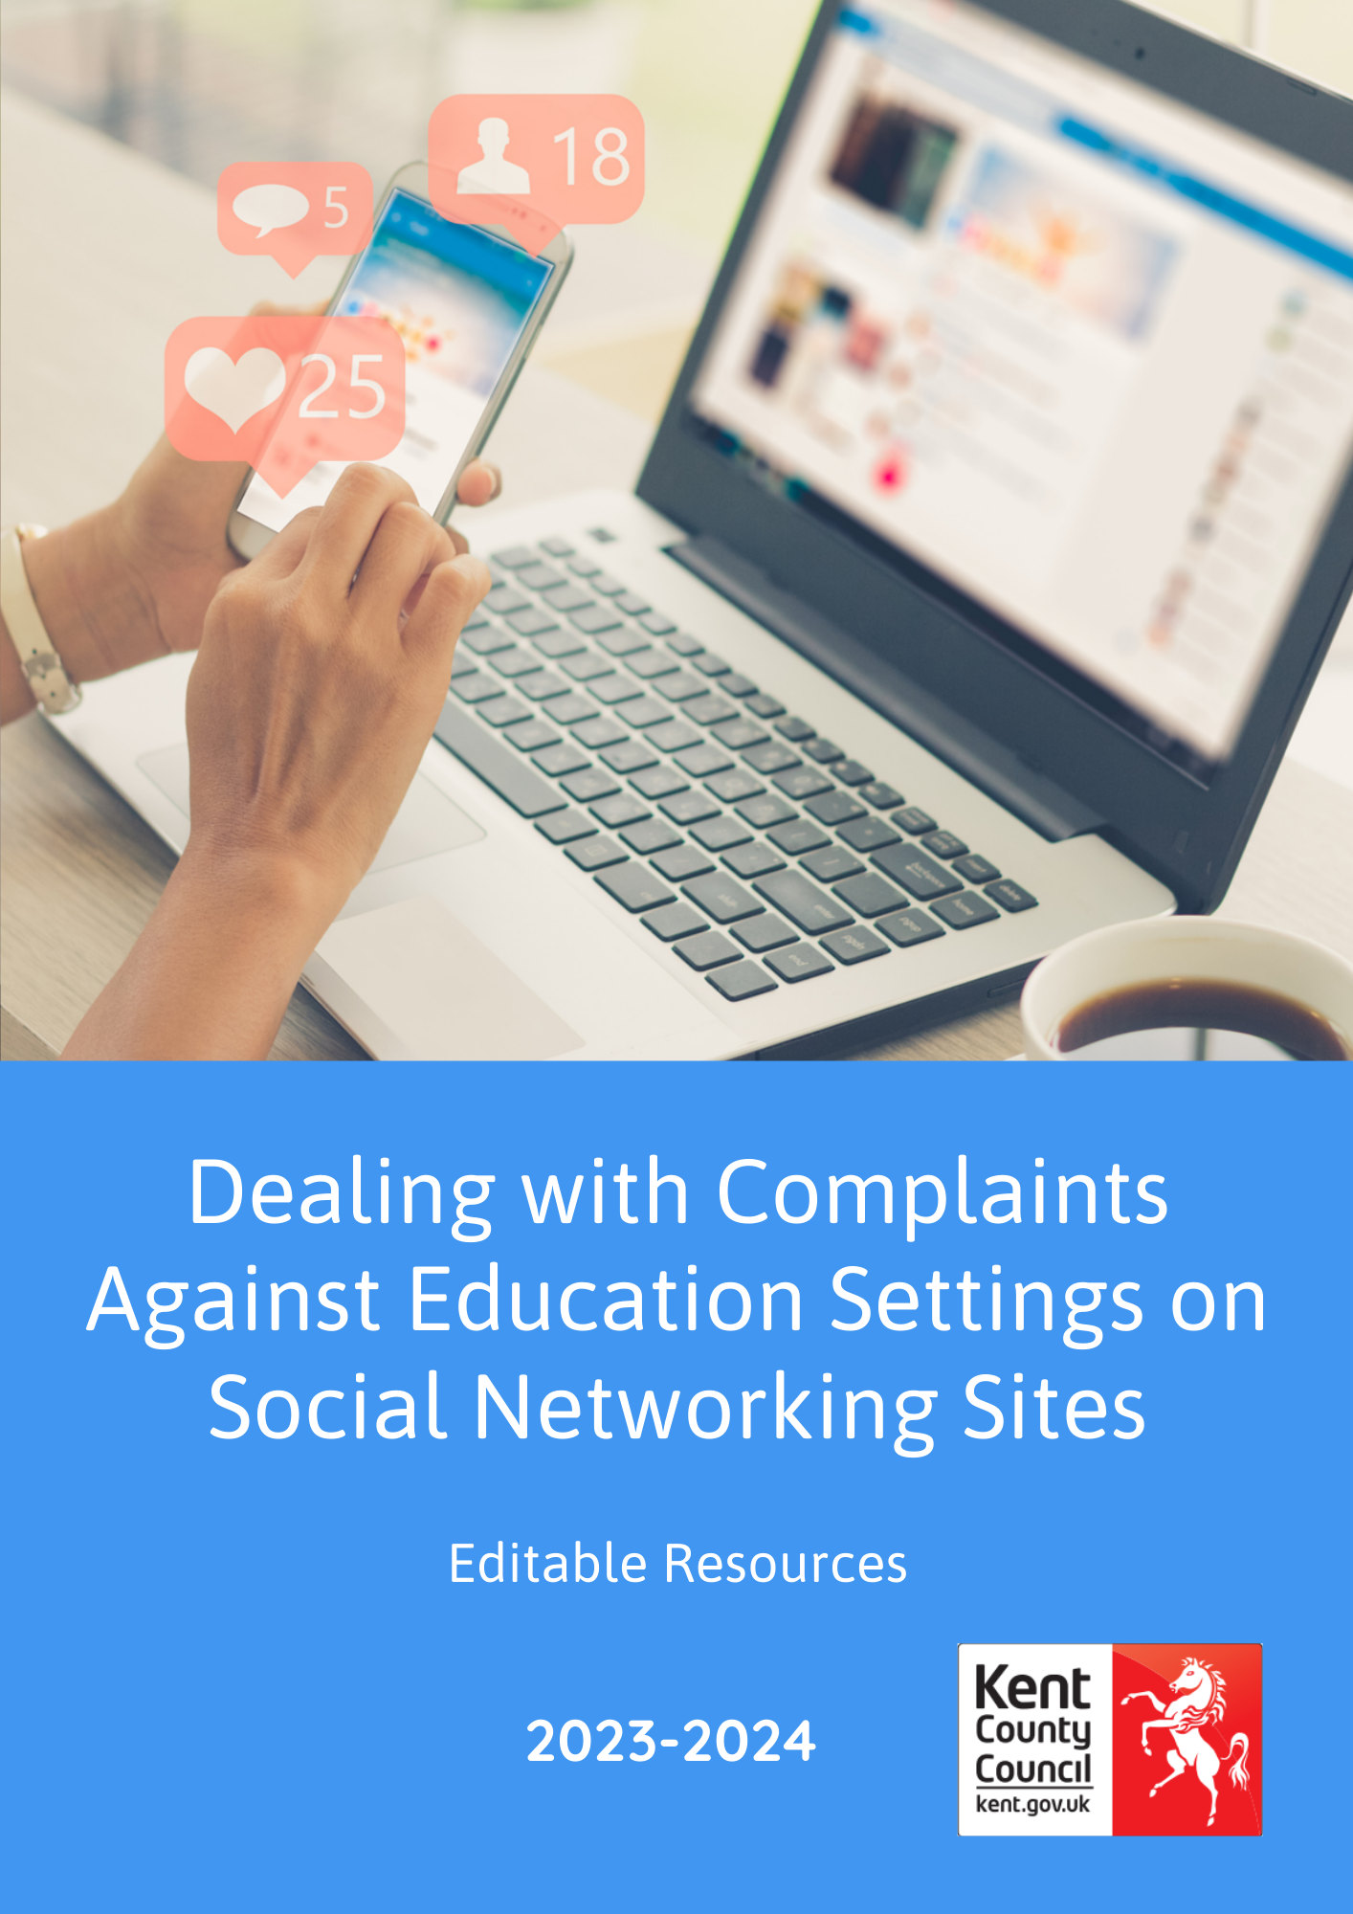

How to use these resources
Please read the current Dealing with Complaints against Education Settings on Social Networking Sites PDF when using and adapting these documents in your setting or school.
Please be aware that settings must not share any information which could compromise a live police or other investigation; please seek advice if this is a concern.

Disclaimer
Kent County Council make every effort to ensure that the information in this document is accurate and up to date. If errors are brought to our attention, we will correct them as soon as practicable.
The copyright of these materials is held by Kent County Council. However, educational settings that work with children and young people are granted permission to use all or part of the materials for not-for-profit use, providing Kent County Council copyright is acknowledged and we are informed of its use.

Preventative Approaches
General Awareness Information for Newsletters
At <school/setting name>we strive to achieve the best for all children; however, we recognise that on some occasions you may feel that we could have done better.
We would be grateful if parents do not use social media to raise complaints but instead, we encourage you to come into school/setting and speak with us so that we can understand your concerns and help solve the problem. Complains on social media can be damaging for the school/setting, its staff and most importantly for the children.
We would like to encourage you to come in and discuss any concerns with us by (insert details for example, speaking with the headteacher/manager). If you feel that an issue has not been dealt with appropriately, we will provide you with a copy of the formal complaint procedures.
General Awareness Letter for all parents
Dear Parent/Carers
Online Safety is an important part of keeping children safe at <school/setting name>. We can only be successful in keeping children safe online if we work with you to ensure that safety messages are consistent and that all members of the community behave safely and appropriately online.
We are writing to you to request your support in ensuring that our children have responsible online role models when posting and sharing content on social media sites. Whilst we are all entitled to have our own views and opinions, we would like to ask that all members of our community consider how our comments may be misunderstood or misinterpreted when shared online, and the possible impact and consequences on others of our online actions.
If parents have any concerns or complaints regarding the school/setting, then we would like to request that they be made using official channels, so we can work together to help resolve the concerns. The complaints procedure, anti-bullying policy and other relevant policies are available online via our website [link] or upon request at the office.
As responsible adults it’s important we all consider the potential impact and implications of online behaviour for ourselves and our families, as well as other members of the community Our school/setting is keen to work in partnership with parents and carers to promote responsible internet use and acknowledge how important your role is in setting a good example of positive and responsible online behaviour for your child.
More information about online safety can be found at the following places:
- www.thinkuknow.co.uk/parents
- www.saferinternet.org.uk
- www.childnet.com
- www.nscpcc.org.uk/onlinesafety
- www.internetmatters.org

If parents/carers wish to discuss this matter further or have any other online safety concerns the please contact [Name] Designated Safeguarding Lead, or myself (if different).
Many thanks in advance for your support in this matter,
[Name]

Headteacher/Manager/Chair of Governors

Letters following specific issues

Do not use this letter if sharing it could identify members of the community and do not send this letter until the parents/carers involved have been spoken with

Template Incident Letter (following a specific issue) for all parents/carers
Dear Parent/Carers
Online Safety is an important part of keeping children safe at <school/setting name>. We can only be successful in keeping children safe online if we work with you to ensure that online safety messages are consistent and that all members of the community behave safely and appropriately online.
Unfortunately, it has been brought to our attention that some parents/carers have been using social media to complain and/or be abusive about the school/setting and/or members of staff/parents/children in the school/setting community. Amend as appropriate – please remember the need for confidentiality; this section can be removed.
Whilst we are all entitled to have our own views and opinions, we would like to ask that all members of our community consider how this may be misunderstood or misinterpreted when shared online and the possible impact and consequences of these actions. Whilst we can continue to raise the profile of online safety, we need the help of the whole community to support us in keeping our wider community safe online.
It is important that all members of our community understand that the use of technology (including social networking, mobile phones, games consoles and other websites) to deliberately threaten, upset, harass, intimidate or embarrass someone else could be viewed as cyberbullying or harassment. Cyberbullying is just as harmful as bullying in the real world and is not tolerated at <school/setting name>. We take all instances of cyberbullying or harassment very seriously as we want all members of our community to feel safe. Posting threatening, obscene or offensive comments online can potentially be considered as a criminal offence and can therefore have serious consequences. Amend as appropriate.
Any complaints should be made using the correct and official channels, so we can work together to help resolve any concerns that parents may have. The complaints procedure, anti-bullying policy and other relevant policies are available online via our website (link) or upon request at the office.
I would like to ask all parents to think carefully about the information and comments they post online. As responsible adults it’s important that we all consider the potential impact and implications posting such content may have on you and your family as well as other members of the community. I would also like to remind all parents about the need for us all to work in partnership to promote responsible internet use. Your role in setting a good example of positive and responsible online behaviour for your child is crucial.
If parents wish to discuss this matter further, or have any other online safety concerns the please contact [Name] Designated Safeguarding Lead, or myself (if different).
Many thanks in advance for your support in this matter,
[Name]
Headteacher/Manager/Chair of Governors
Letter to use with parents specifically involved in concerns
This template should be used with care/caution and only sent if you are unable to meet with parents involved directly, ideally this should be face to face

Dear parent/carer

It has been drawn to my attention that you have recently made comments online on [site] relating to [event]. I enclose a screenshot of the material in question, which you will note has been signed and dated.

I am disappointed that you have chosen to use this medium to express these views and I am greatly concerned about the tone of the comments made and their abusive and threatening nature [substitute for more appropriate adjectives if necessary] relating to another member of our community.

It is important that all members of our community understand that the use of technology (including social networking, mobile phones, games consoles and other websites) to deliberately threaten, upset, harass, intimidate or embarrass someone else could be viewed as cyberbullying or harassment. Cyberbullying is just as harmful as bullying in the real world and is not tolerated by our school/setting. <school/setting name>takes all instances of cyberbullying or harassment involving any members of our community seriously, as we want members of the community to feel safe and happy both on and offline. Amend as appropriate.
Please contact me at your earliest convenience to arrange an appointment as I would appreciate a meeting with you to discuss this matter in an open and constructive manner. I emphasise that the conversation will remain confidential. My colleague [name and role e.g. chair of governors] will be present to act as note-taker, and you may also wish to be accompanied by a family member or friend (if needed). Amend as appropriate.

I am sure that we will be able to resolve this situation and achieve a positive outcome. I look forward to meeting with you.

Yours sincerely,
[Name]
Headteacher/Manager/Chair of Governors

