How to set up an account on CPD Online and The Education People, merge and have one single sign on to both areas.

To go to CPD Online click here

From the home page, 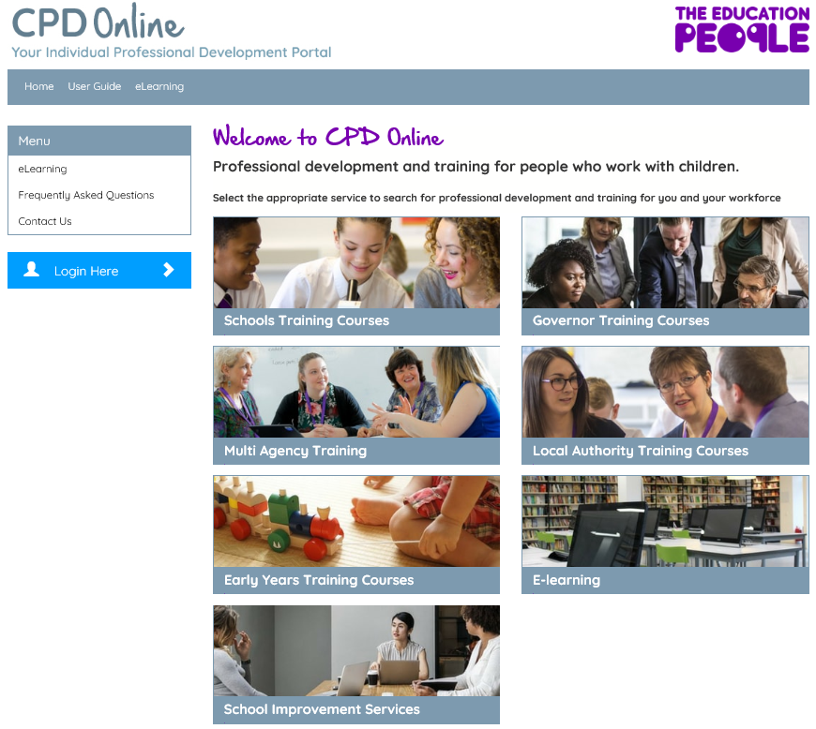

Click Login Here and you will be automatically taken to The Education People’s log in screen

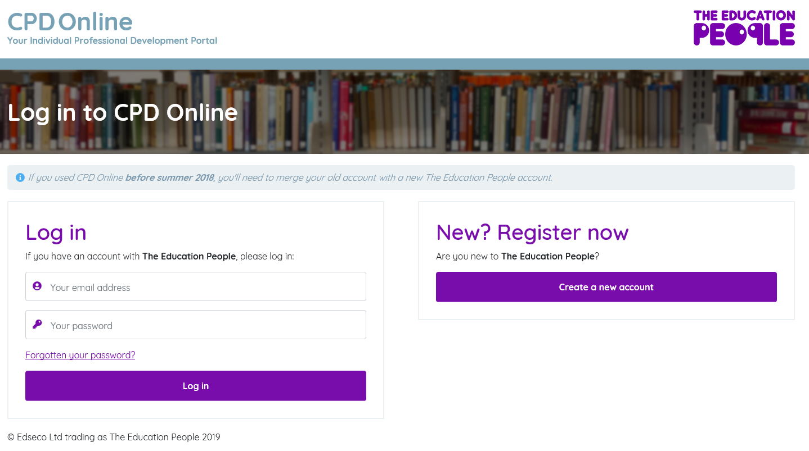

Click Create a new account

Complete the form (guidance shown below form)
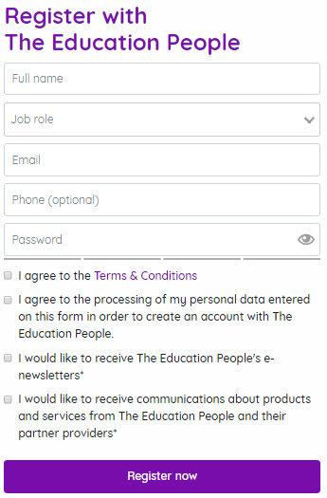

Under Job role click on Teacher or school staff:
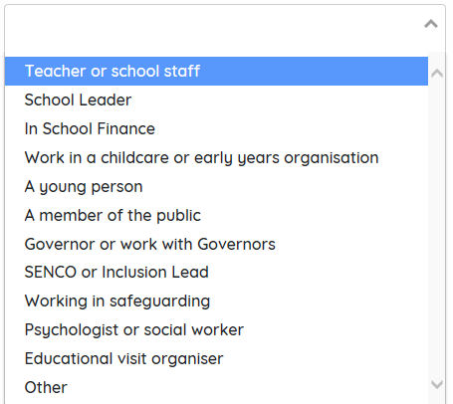

Under Organisation Type click on Primary School:
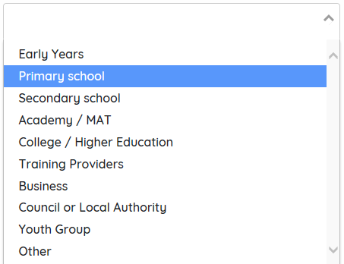

Under School type your school postcode
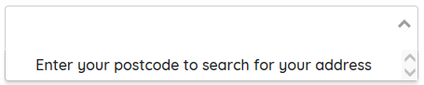
If the address does not show up, click on I can’t find my address and fill in your address details

Type your email address, phone number and create a password. Your password can be checked by clicking on the
Symbol and remember this is case sensitive.

Tick at least the top two statements and then on Register now
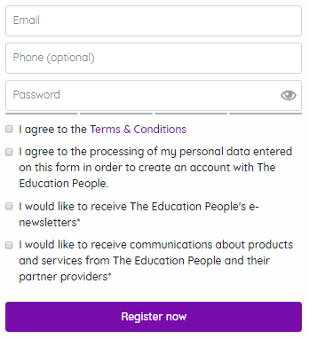

Once you have completed the registration process above, you will be taken back to home page to log in. Please enter your email address and password you have just created.

Once you have looged in, you will see the following screen:

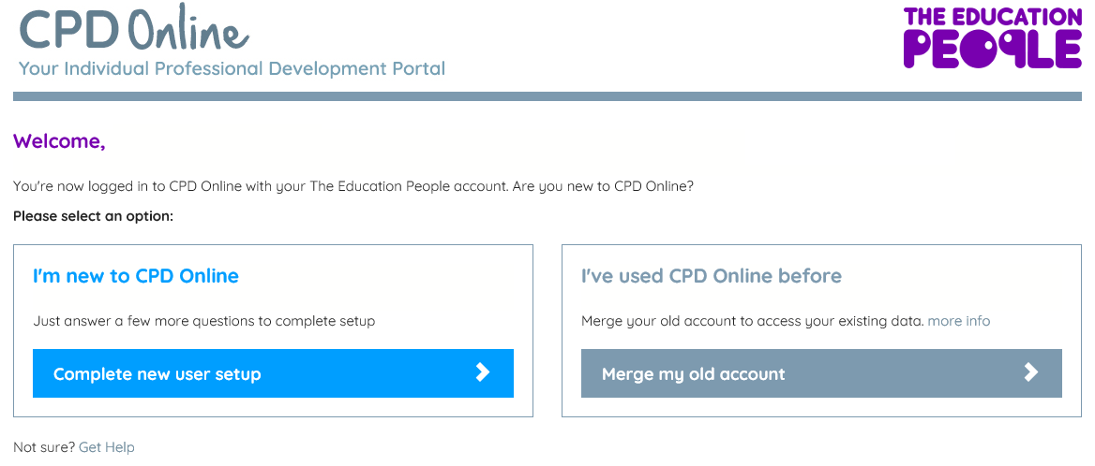

If you are competely new to CPD Online, click on
If you have used CPD Online before, please click on

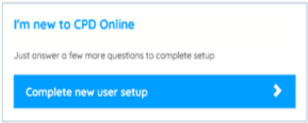
Complete the following and click on Continue
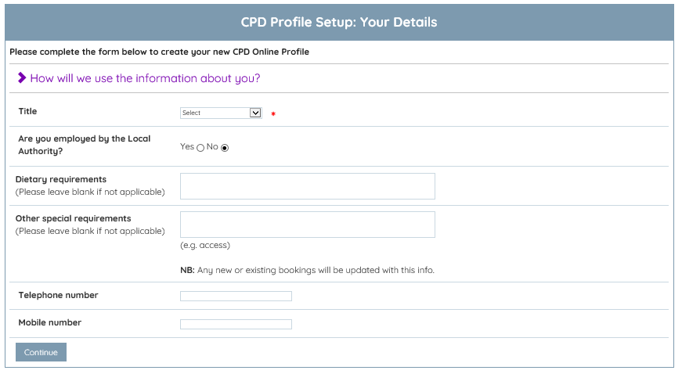

Complete the following page and click on Continue
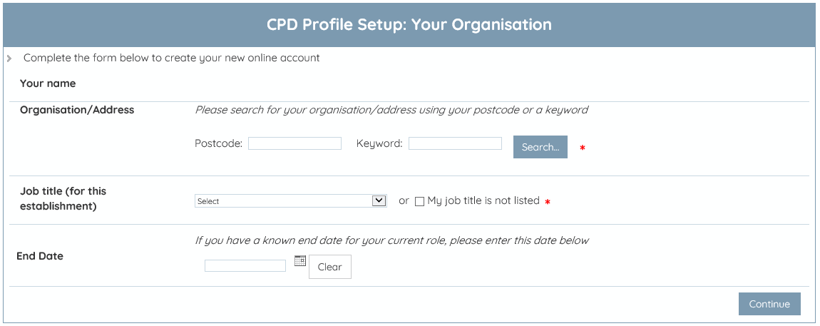

Your CPD Online account is now complete and ready for you to use.

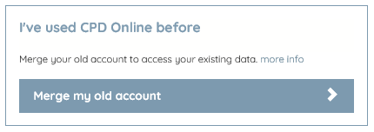

Complete the following and click Merge Now
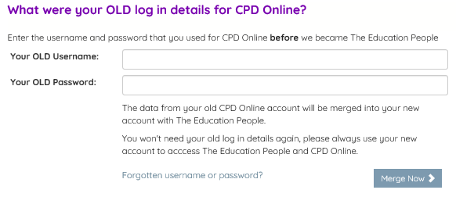

If you cannot remember your user details, please contact the CPD helpdesk on 03000 418000 and they will be able to assist you.

Once you have clicked ‘Merge Now’, your Education People account and CPD Online acounts have been merged and you will now login to either site with this one email address and password.

