How to set up an account on CPD Online and Link this with your account with The Education People

Once you have looged in, you will see the following screen:

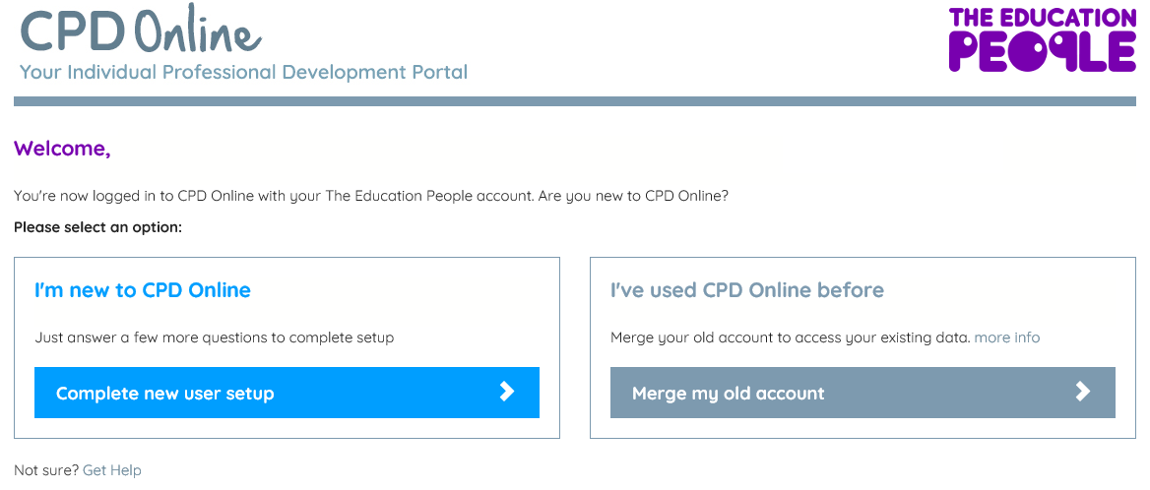

If you are competely new to CPD Online, click on

If you have used CPD Online before, please click on

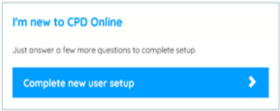

Complete the following and click on Continue
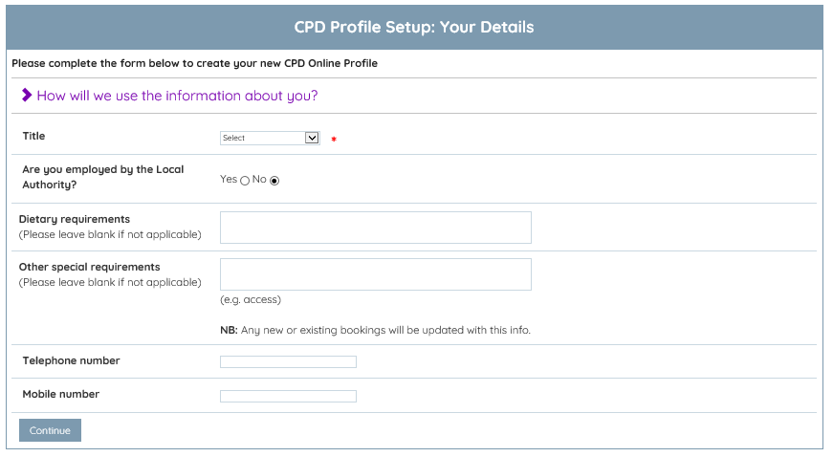

Complete the following page and click on Continue
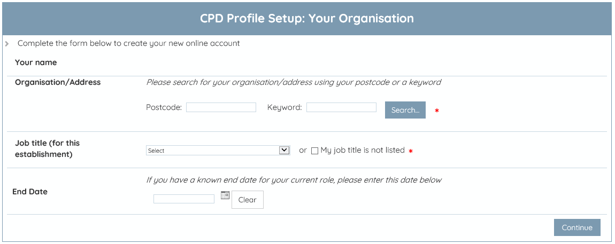

Your CPD Online account is now complete and ready for you to use.

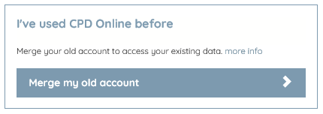

Complete the following and click Merge Now
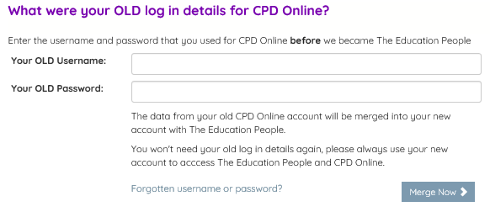

If you cannot remember your user details, please contact the CPD helpdesk on 03000 418000 and they will be able to assist you.

Once you have clicked ‘Merge Now’, your Education People account and CPD Online acounts have been merged and you will now login to either site with this one email address and password.

