Threads of Success Virtual Training Update
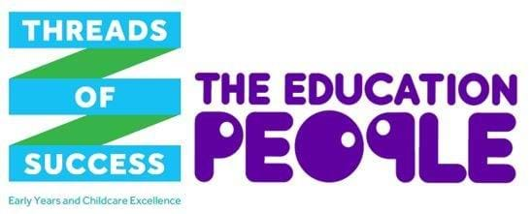

Please find below an update of all virtual training courses taking place over the next couple of months that still have available places. To read more, or book your place please click on the links below.

Course code | Date | Time | Area
I CAN Early Talk Boost Training
EYC 20/228 | 19/11/2020 | 9.30am to 12.30pm | Online
Global Goals Workshop – Life on Land
EYC 20/249  EYC 20/250 | 02/12/2020  09/12/2020 | 1.30pm to 2.30pm  10am to 11am | Online
Are You Ready for Your Inspection? (Two Sessions)
EYC 20/167 | 02/12/2020 | 9.30am to 12.30pm | Online

Magic of Maths
EYC 20/231 | 07/12/2020 | 10am to 1pm | Online
A Practical Guide for Early Years Special Educational Needs Coordinators
EYC 20/248  EYC 21/024 | 09/12/2020  28/01/2021 | 9.30am to 12.30pm  1.30pm to 4.30pm | Online

Marketing and Promotion for Success
EYC 21/126 | 19/01/2021 | 9.30am to 12.30pm | Online
How to Break Even and Avoid Bad Debt
EYC 21/144 | 19/01/2021 | 1.30pm to 4.30pm | Online
A Successful Charity
EYC 21/065 | 20/01/2021 | 9.30am to 12.30pm | Online
Sound Talk - Exploring Aspect 7 Letters and Sounds
EYC 21/125 | 20/01/2021 | 1.30pm to 4.30pm | Online
Equality and Diversity in the Early Years
EYC 21/049 | 23/01/2021 | 9.30am to 12.30pm | Online
Walking in the Shoes of Giants
EYC 21/049 | 23/01/2021 | 9.30am to 12.30pm | Online
Ofsted Education Framework (EIF) Quality of Education
EYC 21/055 | 25/01/2021 | 10am to 1pm | Online
Making Accurate Assessments in the Early Years - Following COVID-19
EYC 21/131 | 26/01/2021 | 9.30am to 12.30pm | Online

The Kent County Council funded offer
The Kent County Council (KCC) funded offer via The Education People is available to providers of early education and/or childcare within KCC’s geographical boundaries, registered with Ofsted or the Department for Education and/or with KCC to deliver Free Entitlement places; this includes:
- Private, voluntary and independent group providers
- Out of school childcare providers
- Eligible childminders
- Schools and academies admitting children under four.
*Please note that non-eligible childminders can access some elements of the offer only.

