Threads of Success Virtual Training Update September-December 2020
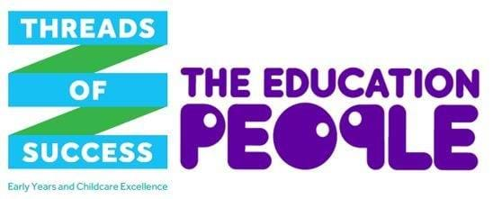

Please find below an update of all virtual training courses taking place over the next couple of months that still have available places. To read more, or book your place please click on the links below.

Course code | Date | Time | Area
Children's Behaviour as a Communication
EYC 20/198 | 29/10/2020 | 9.30am to 12.30pm | Online
Ofsted Education Inspection Framework (EIF) - Leadership and Management
EYC 20/224 | 09/11/2020 | 12.30am to 3.30pm | Online
Makaton Level One (two sessions)
EYC 20/232 | 10/11/2020 | 9.50am to 2pm | Online
Walking in the Shoes of Giants
EYC 20/191 | 16/11/2020 | 9.30am to 12.30pm | Online
A Practical Guide for Early Years Special Educational Needs Coordinators
EYC 20/175 | 17/11/2020 | 9.30am to 12.30pm | Online
I CAN Early Talk Boost Training
EYC 20/228 | 19/11/2020 | 9.30am to 12.30pm | Online
Are You Ready for Your Inspection? (two sessions)
EYC 20/167 | 02/12/2020 | 9.30am to 12.30pm | Online
Magic of Maths
EYC 20/231 | 07/12/2020 | 10am to 1pm | Online

The Kent County Council funded offer
The Kent County Council (KCC) funded offer via The Education People is available to providers of early education and/or childcare within KCC’s geographical boundaries, registered with Ofsted or the Department for Education and/or with KCC to deliver Free Entitlement places; this includes:
- Private, voluntary and independent group providers
- Out of school childcare providers
- Eligible childminders
- Schools and academies admitting children under four.
*Please note that non-eligible childminders can access some elements of the offer only.

