Webinar Frequently Asked Questions

What happens when I sign up?
- You should receive an email confirming your booking, what the booking is for and there will be a link to check your system requirements. It is advisable to do this as soon as you register, so you know it all works before the webinar.

- Within this email will be a Join Webinar button which you will need to click at the specified time and date of the Webinar you have booked onto.

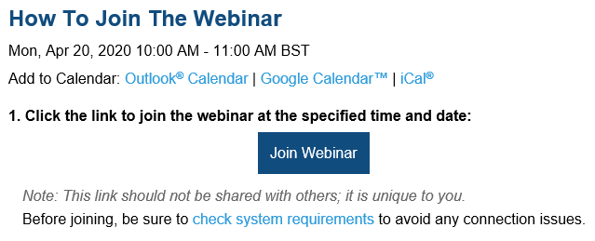

There will also be information regarding your audio options:
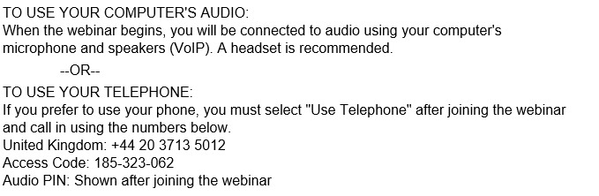

How to Join a Webinar
https://support.goto.com/webinar/help/how-to-join-a-webinar-g2w030002

I can’t join my session
https://support.goto.com/webinar/help/i-cant-join-my-session-g2w060002

Why can I hear audio but not see the presentation?
https://support.goto.com/webinar/help/why-can-i-hear-audio-but-not-see-the-presentation-g2w050052

Why can’t I hear anyone?
https://support.goto.com/webinar/help/why-cant-i-hear-anyone-g2w050056

How do I fix audio feedback (echo, static) during my session?
https://support.goto.com/webinar/help/how-do-i-fix-audio-feedback-echo-static-during-my-session-g2w050049

