Threads of Success training update March 2020
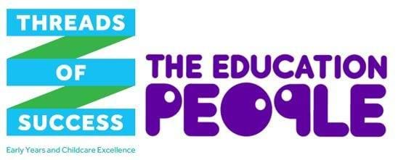

Please find below an update of courses taking place over the next couple of months that still have available places. To read more, or book your place please click on the links below.

Best practice guidance workshop for settings and childminders
Course code | Date | Time | Area
EYC 20/132  EYC 20/134  EYC 20/137  EYC 20/138  EYC 20/139  EYC 20/144  EYC 20/145  EYC 20/146 | 09.03.2020  10.03.2020  23.03.2020  24.03.2020  25.03.2020  20.04.2020  27.04.2020  29.04.2020 | 09:30 - 12:30  19:30 - 21:30  19:30 - 21:30  19:30 - 21:30  19:30 - 21:30  19:30 - 21:30  19:30 - 21:30  19:30 - 21:30 | Swale (settings)  Canterbury (childminder)  Ashford (childminder)  Dartford (childminder)  Sittingbourne (childminder)  Folkestone (childminder)  Dover (childminder)  Tonbridge (childminder)
A successful charity

EYC 20/047 | 04.03.2020 | 09:30-12:30 | Dartford
Entering or developing? making accurate judgements in the early years

EYC 20/070 | 05.03.2020 | 09:30-12:30 | Maidstone
Targeted support for communication and language

EYC 20/090 | 10.03.2020 | 09:30-12:30 | Maidstone
EYC 20/130 | 11.03.2020 | 09:30-16:30 | Maidstone
Early identification of children with SEND

EYC 20/092 | 12.03.2020 | 09:30-12:30 | Maidstone
I CAN early talk boost practitioner training

EYC 20/088 | 17.03.2020 | 09:30-15:30 | Thanet
Early years special educational needs coordinator training (advanced)

EYC 20/018 | 19.03.2020 | 09:30-15:30 | Ashford
Encouraging positive behaviour training

EYC 20/086 | 25.03.2020 | 09:30-12:30 | Maidstone
Global goals workshop

EYC 20/150  EYC 20/151  EYC 20/152  EYC 20/153 | 25.03.2020  25.03.2020  26.03.2020  26.03.2020 | 10:00-12:00  13:00-15:00  10:00-12:00  13:00-15:00 | Ashford  Ashford  Ashford  Ashford

Course code | Date | Time | Area
Supervision and appraisals

EYC 19/303 | 24.03.2020 | 09:30-12:30 | Sevenoaks
Loose parts

EYC 20/031 | 16.04.2020 | 09:30-12:30 | Canterbury
Introduction to forest school

EYC 20/028 | 20.04.2020 | 09:30-12:30 | Tunbridge Wells
The linguistic child - loving language

EYC 20/027 | 21.04.2020 | 09:30-16:30 | Canterbury
Sustained shared thinking: Why are clouds fluffy?

EYC 20/045 | 22.04.2020 | 09:30-16:30 | Maidstone
Unlocking outstanding potential - Pathway to excellence

EYC 20/042 | 29.04.2020 | 09:30-16:30 | Ashford

For more training and group booking please click here >>

The Kent County Council funded offer
The Kent County Council (KCC) funded offer via The Education People is available to providers of early education and/or childcare within KCC’s geographical boundaries, registered with Ofsted or the Department for Education and/or with KCC to deliver Free Entitlement places; this includes:
- Private, voluntary and independent group providers
- Out of school childcare providers
- Eligible childminders
- Schools and academies admitting children under four.
*Please note that non-eligible childminders can access some elements of the offer only.

